1. Listing the files which are present in the Directory.

Here, there are 2 .pdf files and 1 image present.

The .sh file is the Script which we want to execute.

2. Running the .sh script.

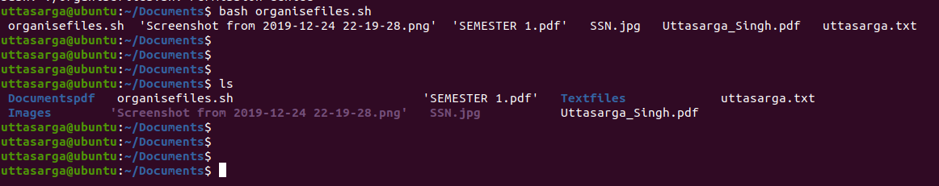
Here, the command was executed which resulted in creation of three different directories namely:
1. Documentspdf
2. Textfiles
3. Images.

3. Files are Copied in the required manner.

